07/31 WK2 Client Meeting

|  |  |
| --- | --- |
| **Location** | Goterra office and Goterra factory |
| **Date** | 31/07/2019 |
| **Time** | 15:00 - 17:00 |
| **Attendees** | Derek Tan, Lily Zhang,  Jessica Ying, Andre Olivier  Olympia Yarger (client),  Jiefei Wang (client),  Martin Amidy (client) |

## Agenda items

1. Visit the client office
2. Set up regular meeting times with the client
3. Ask about the project detail and specifications
4. Visit the client factor

## 1. Visit the client office

## Martin picked up the group members from ANU campus and drove us to the Goterra office. It is located at Fyshwick.

## 2. Set up regular meeting times with the client

Possibly meet again next Wednesday as well. Martin will send everyone a follow-up email to confirm with this.

## 3. Project detail and specifications

* We will agree on a baseline solution in the next client meeting. The client will be satisfied if we meet the baseline requirement. It would be better if we can something more than that.
* The aim of the project is to design a portable design that is a miniaturised version of a full-scale factory.
* Pressure and heat are the two key factors to consider during the design phase.
* Olympia will send us the specification drawing of a full-scale factory
* The expected final products are oil and meal. The by-products may include the shell of the insects and wastewater.
* The processing rate is one of the key factors to measure the productivity of the design.
* During the meeting, Jessica proposed to simplify the design. The client thinks that simplifaction and integration are good as technology keeps evolving. But the quality of the final product needs to at least stay at the same level if not better.
* The final design needs to be able to fit in a 40ft container
* We can use whatever software that we see fit. There is no specific requirement. Solidworks is a good option.
* It would be good if we can specify the tolerances of the final design to make it easier for the next team.
* The entire project will be a multi-semester long project. It is important to keep everything well documented so the next team can pick up easily.

## 4. Visit the client factor

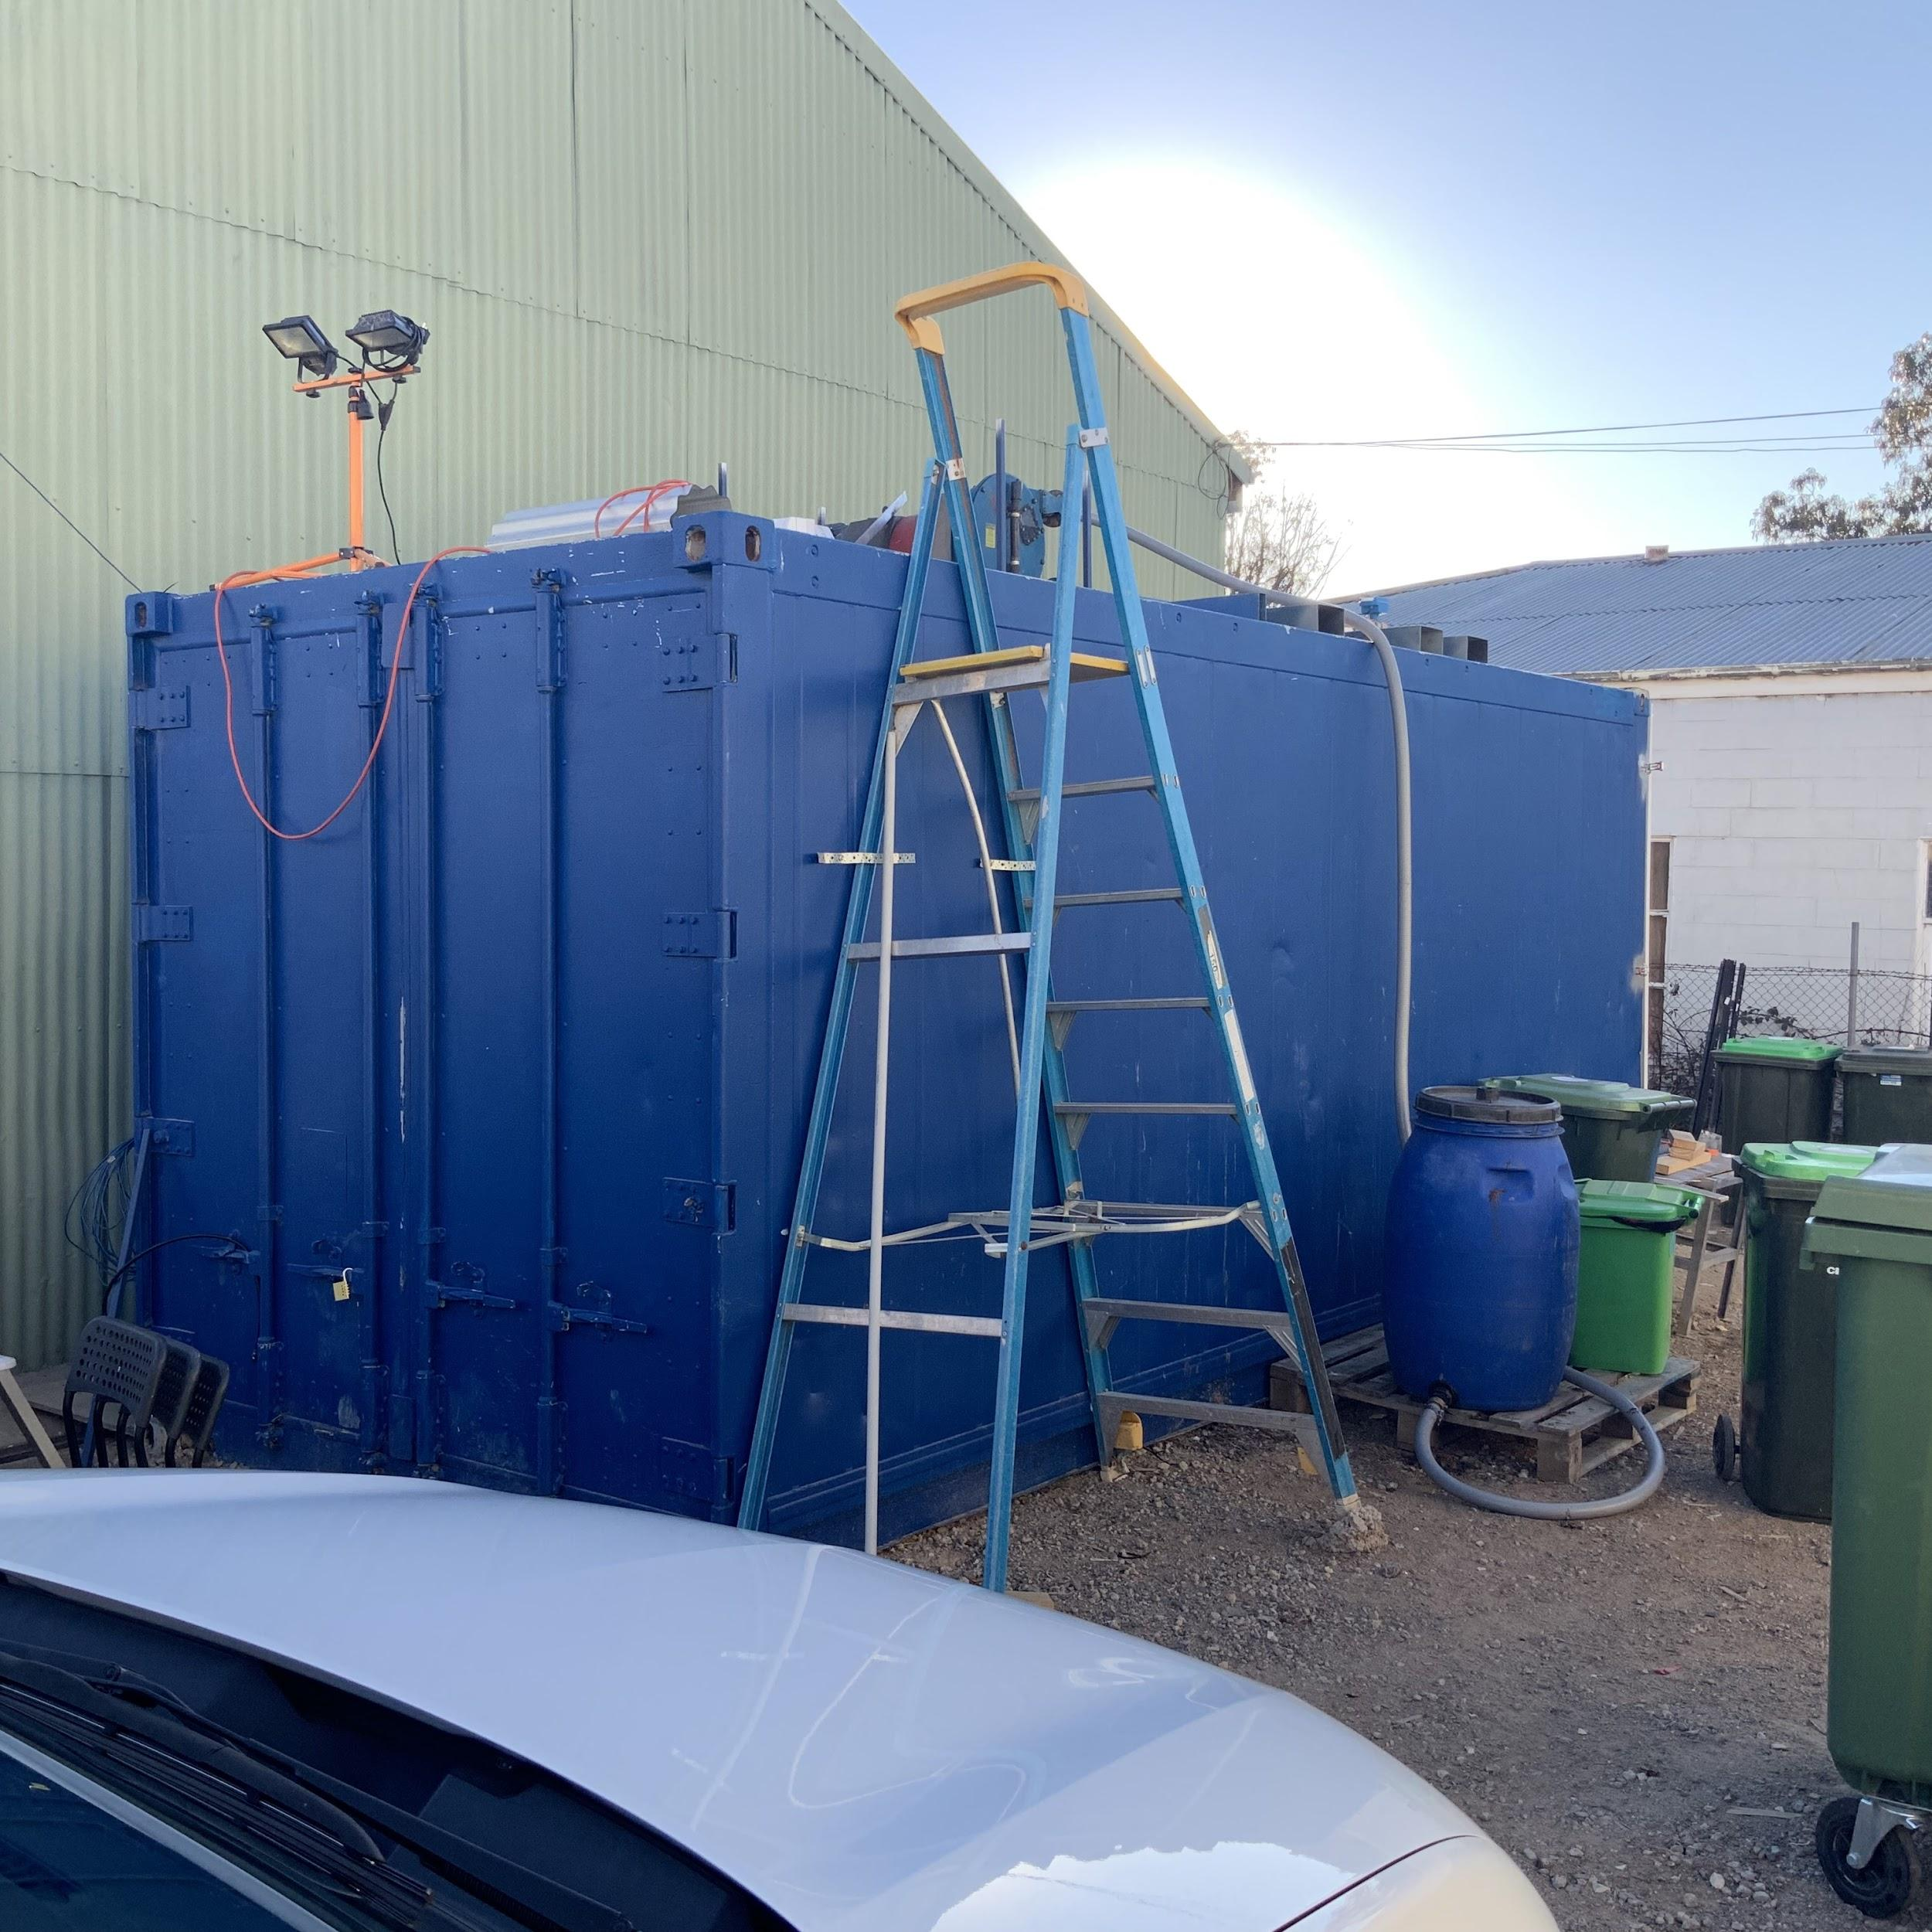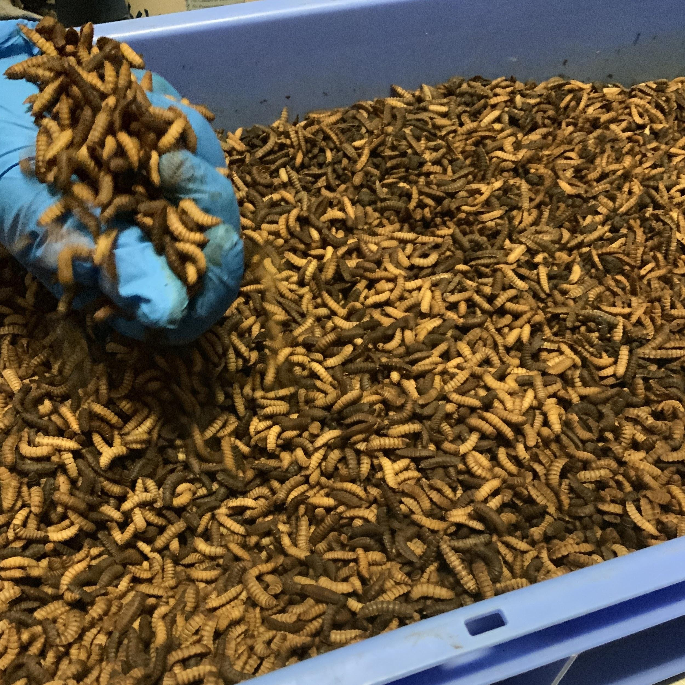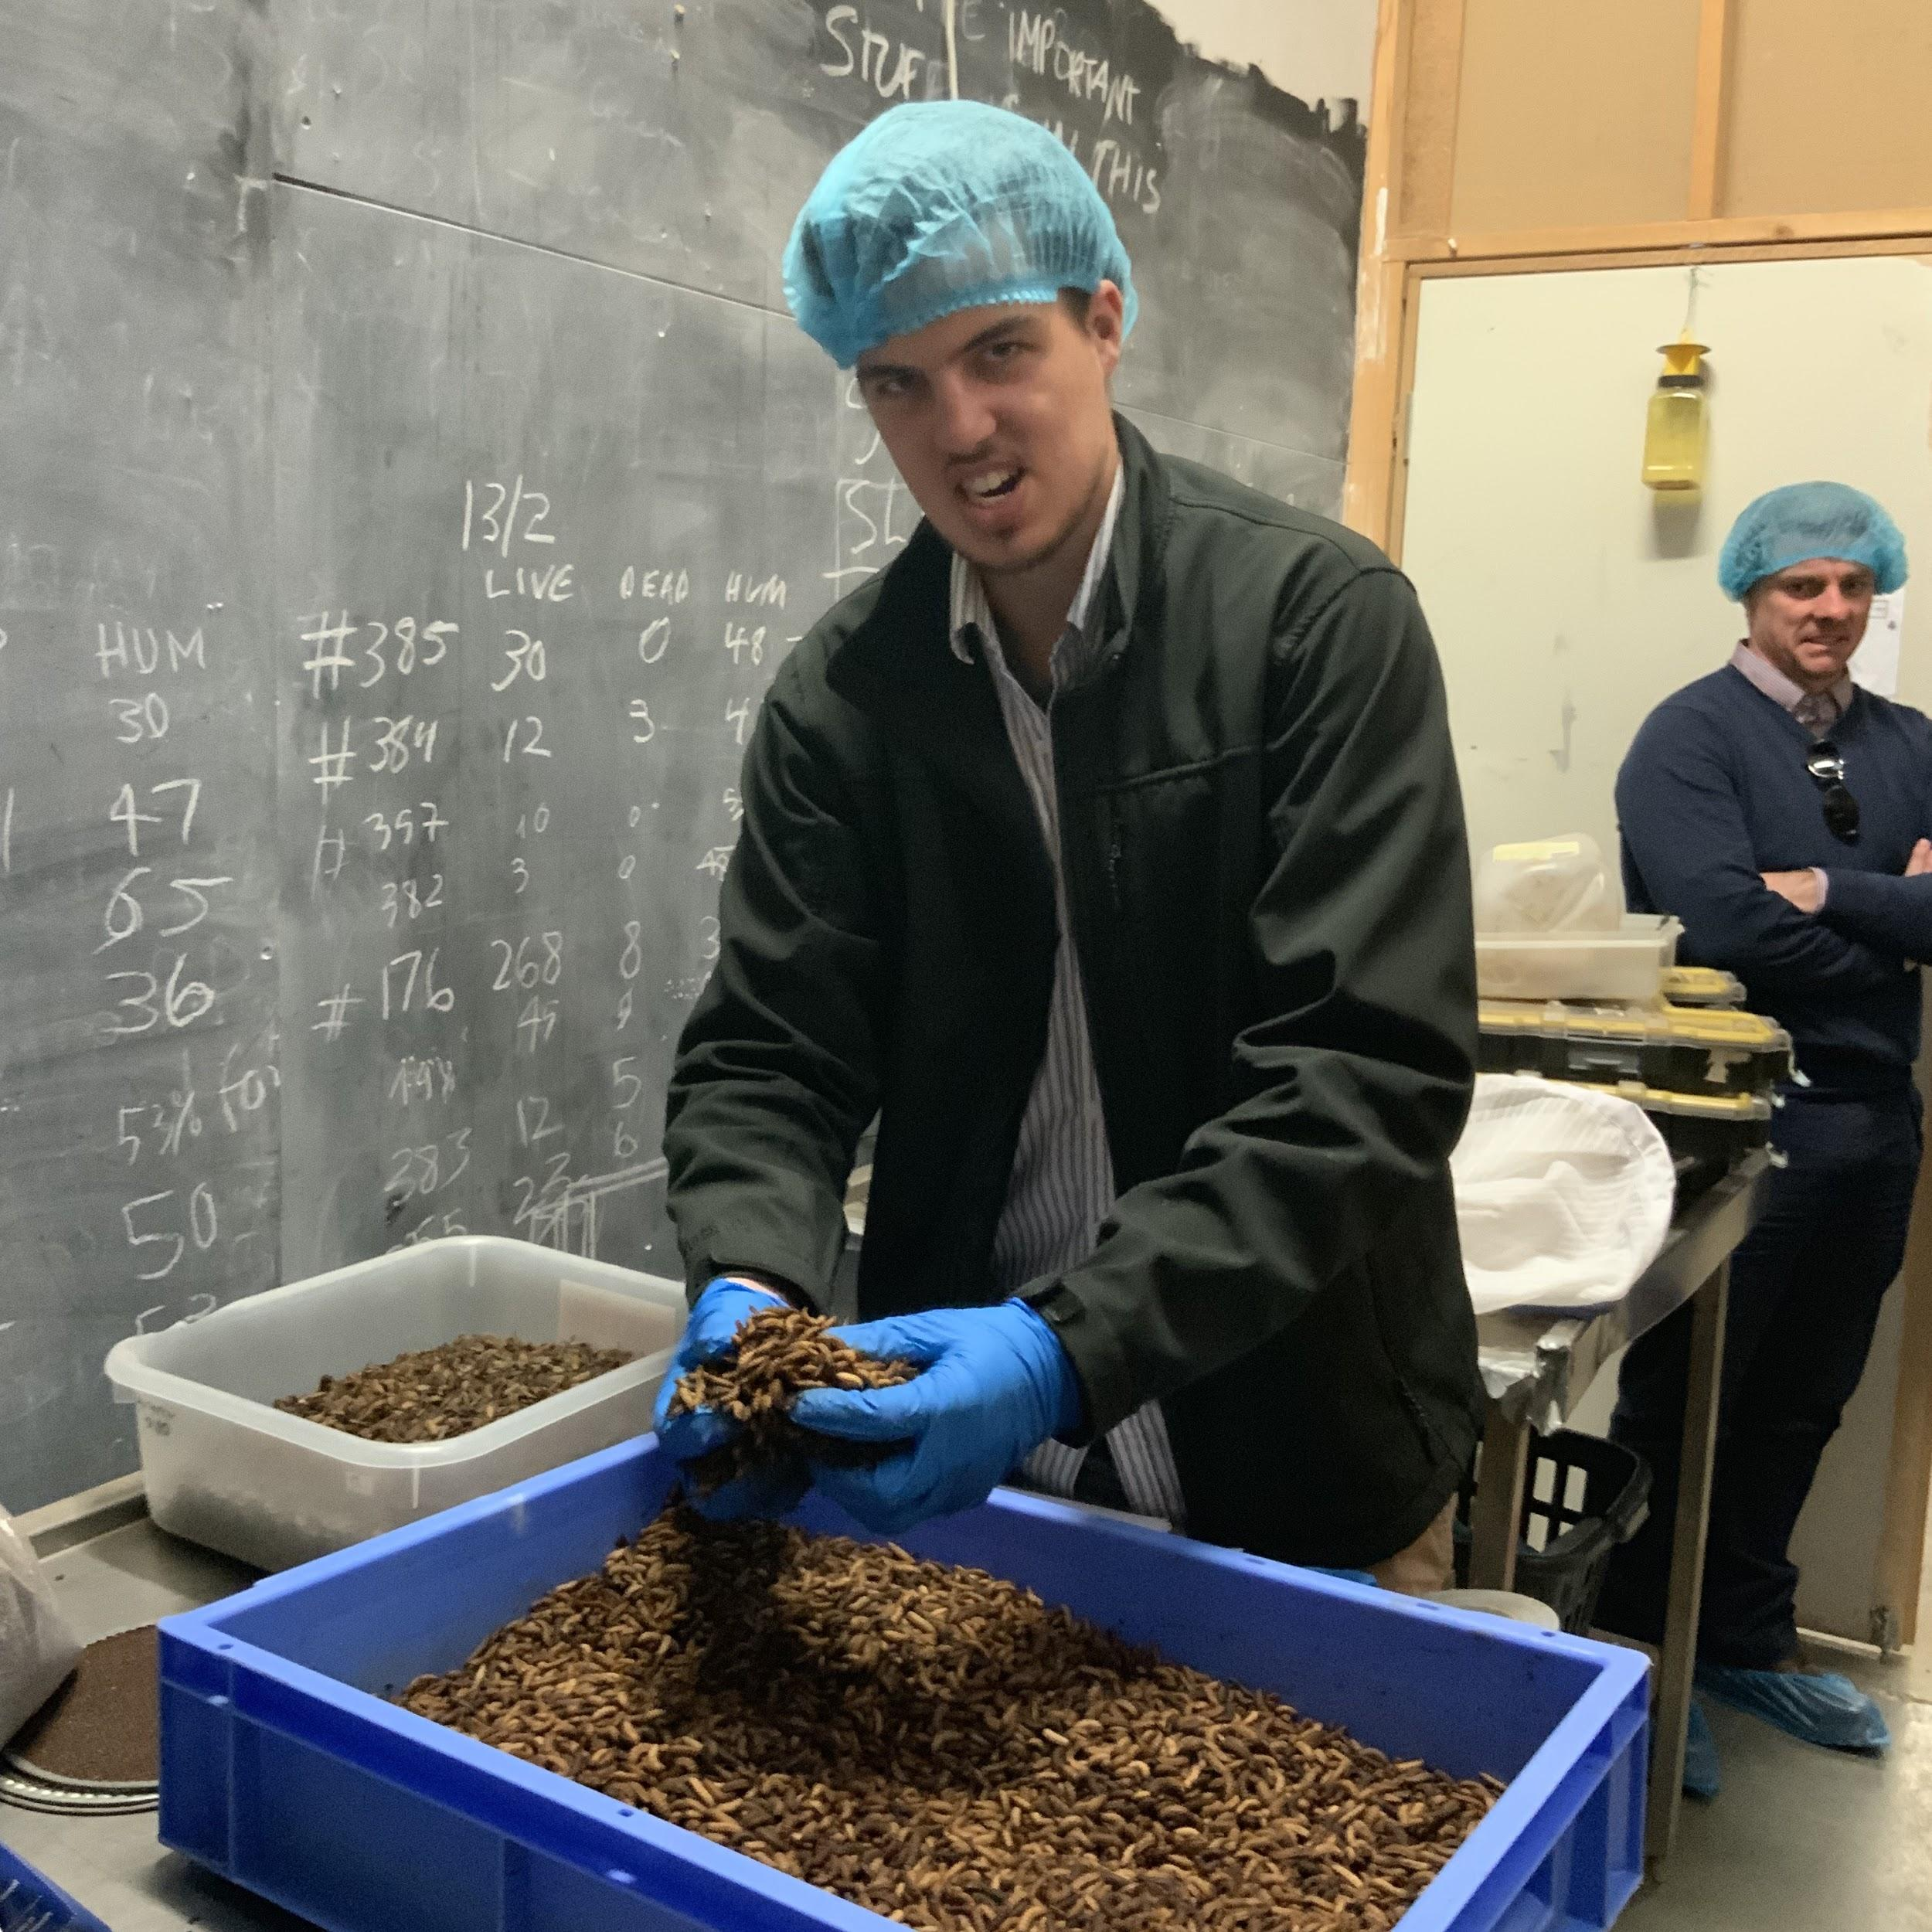

* The factory converts food waste to pet feed.
* The client currently does not have a rendering plant. Thus they want our design team to come up with a solution.
* The general idea is that insects eat food waste, then we render the insects to get meal and oil.

|  |  |  |  |
| --- | --- | --- | --- |
| **Action item** | **Owner** | **Deadline** | **Status** |
| Send us the specification drawing of a full-scale factory | Olympia | 05/08/2019 |  |
| Send everyone a follow-up email to confirm the meeting time | Martin | 05/08/2019 |  |